**Supervised learning:**

Supervised learning, also known as supervised machine learning, is a subcategory of machine learning and artificial intelligence. It is defined by its use of labeled datasets to train algorithms that to classify data or predict outcomes accurately.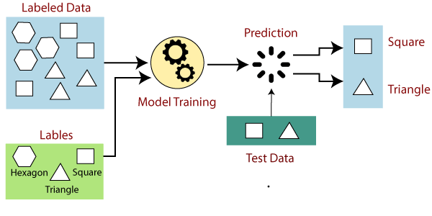

**Types of supervised learning:**

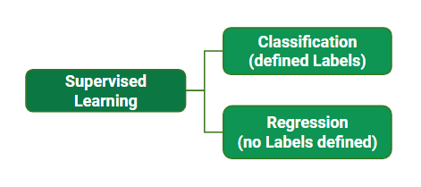

**Classification:**

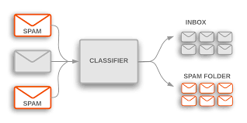When the output variable is categorical i.e. with 2 or more classes (yes/no, true/false) we make use of classification**.**

**Regression:**

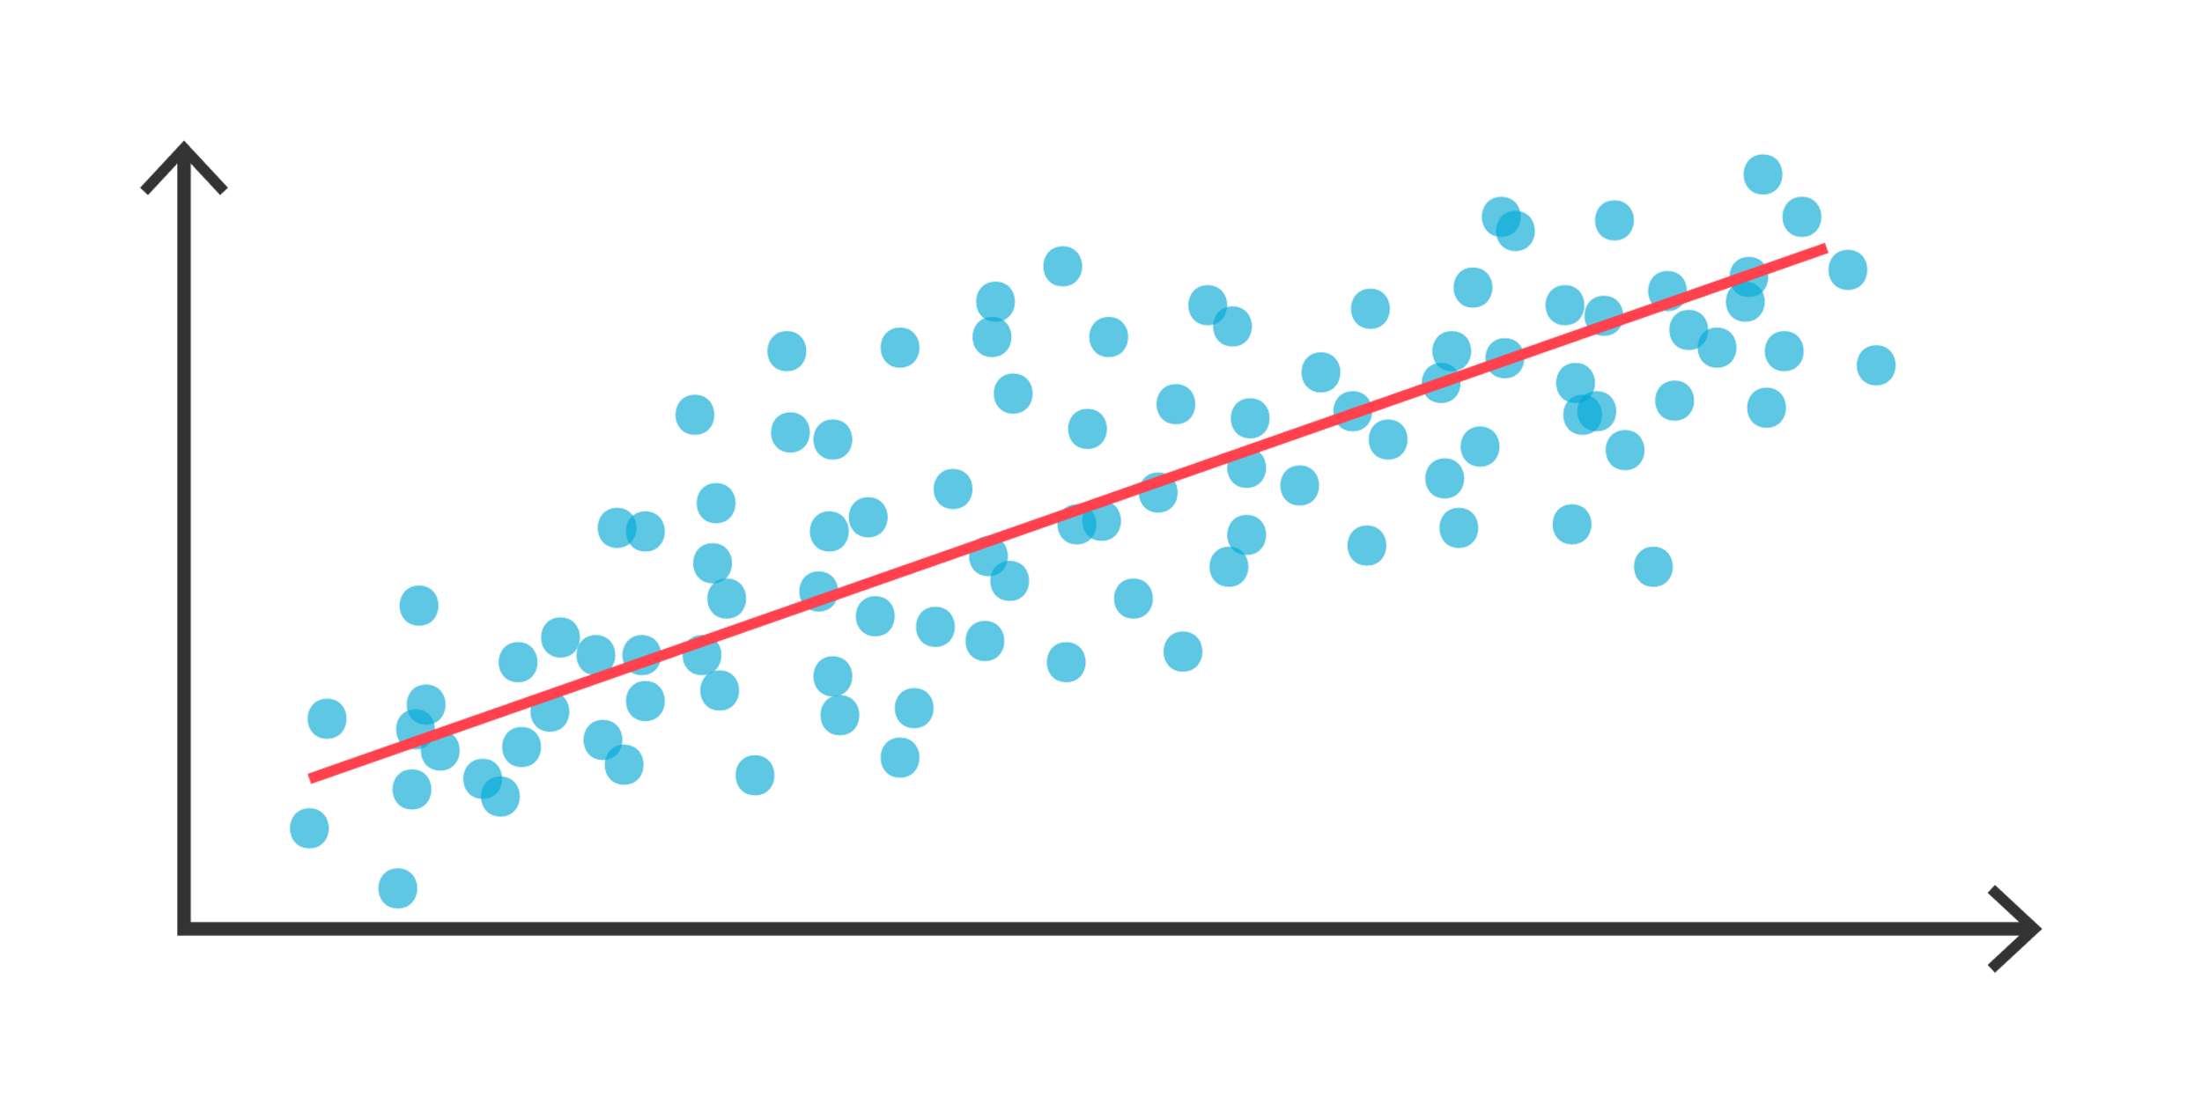Relationship between two or more variables where a change in one variable is associated with a change in one variable .

**Unsupervised learning**

Unsupervised learning, also known as unsupervised machine learning, uses machine learning algorithms to analyze and cluster unlabeled datasets. These algorithms discover hidden patterns or data groupings without the need for human intervention.

**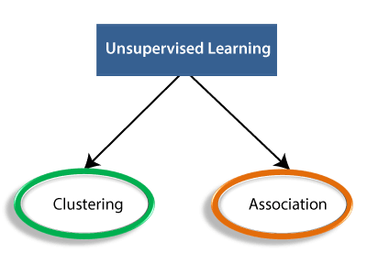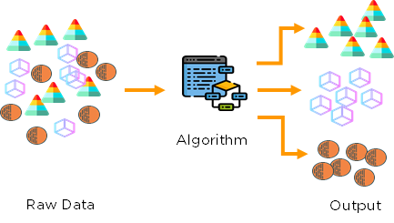  
Unsupervised learning types:**

**Clustering:**

The method of dividing the objects into clusters which are similar between them and are dissimilar to the objects belonging to another cluster.

Suppose a telecom company wants to reduce its customer churn rate by providing personalized call and data plans .

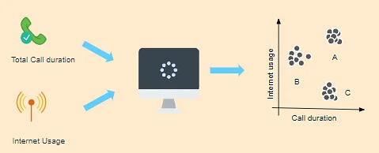

**Association:**

Discovering the probability of the co-occurrence of items in a collection.

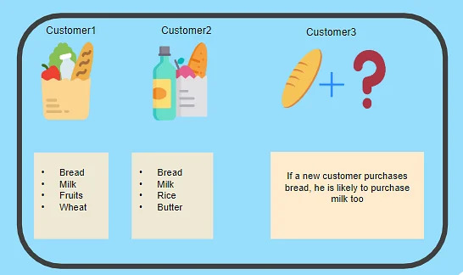

**Regression:**

Regression is a technique for investigating the relationship between independent variables or features and a dependent variable or outcome.

* Relationship: Height $→$ weight?
* Linear?
* Predict: Weight → Height

**Regression Applications:**

* Payments →Credit scores
* Time →Subscriptions
* Grades →Landing a job
* Quantitative output
* Previous input -output observations

**Clustering:**

* Clustering: grouping objects in clusters
* Similar within clusters
* Dissimilar between clusters
* Example: grouping similar animal photos
* No labels
* No right or wrong
* Plenty possible clusterings

**K-Means:**

Clustersdata in K clusters!

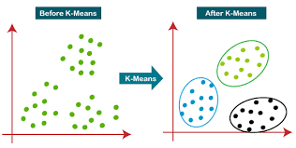

**Deep learning**

Deep learning is a machine learning technique that teaches computers to do what comes naturally to humans.

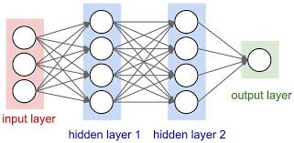

**Types of Deep learning:**

1. Multi-Layer Perceptions (MLP)
2. Convolutional Neural Networks (CNN)
3. Recurrent Neural Networks (RNN)

**Artificial Neural network**

A neural network is a series of algorithms that endeavors to recognize underlying relationships in a set of data through a process that mimics the way the human brain operates. In this sense, neural networks refer to systems of neurons, either organic or artificial in nature.

**Types of Neural networks**

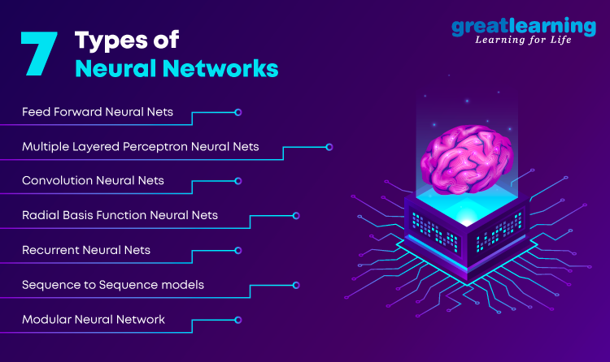

**Recurrent neural Network**

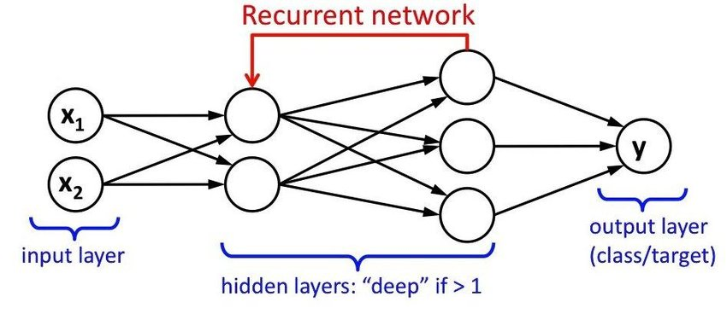A Recurrent Neural Network is a type of neural network that contains loops, allowing information to be stored within the network. In short, Recurrent Neural Networks use their reasoning from previous experiences to inform the upcoming events. Recurrent models are valuable in their ability to sequence vectors, which opens up the API to performing more complicated tasks.

**Long short Term memory Networks:**

Long short-term memory (LSTM) belongs to the complex areas of Deep Learning. It is not an easy task to get your head around LSTM. It deals with algorithms that try to mimic the human brain the way it operates and to uncover the underlying relationships in the given sequential data.

**LSTM Applications:**

1. Language modeling
2. Machine translation
3. Handwriting recognition
4. Image captioning
5. Image generation using attention models
6. Question answering
7. Video-to-text conversion
8. Long short-term memory (LSTM) belongs to the complex areas of Deep

**Python flask:**

**Python flask:**

* Flask is a web framework, it’s a Python module that lets you develop web applications easily. It’s has a small and easy-to-extend core: it’s a microframework that doesn’t include an ORM (Object Relational Manager) or such features.
* It does have many cool features like URL routing, template engine. It is a WSGI web app framework.

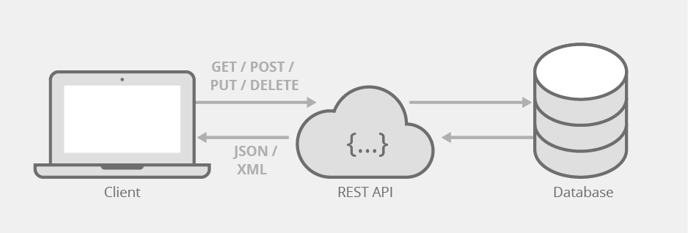

**Python flak Routing:**

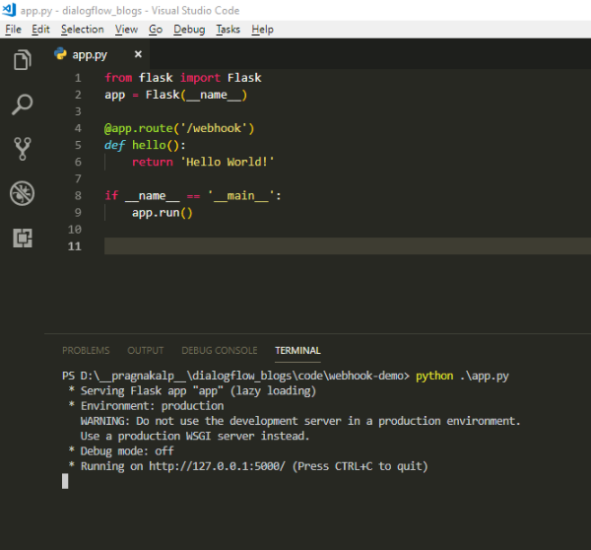 App routing is used to map the specific URL with the associated function that is intended to perform some task.

**Flask Variable Rules:**

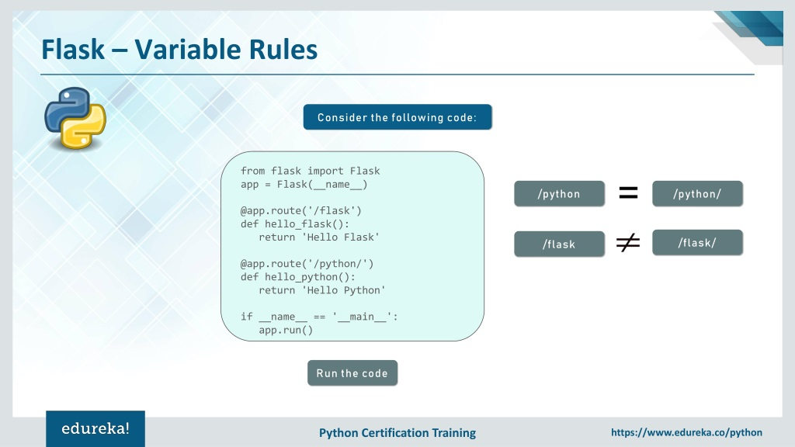

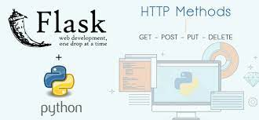**Flask HTTP Method:**